What will we be learning?  Materials  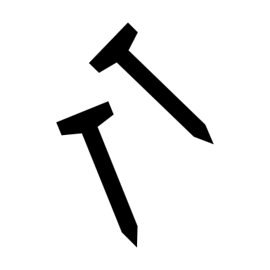 | Why this? Why now?  Previous Learning  Forces, Energy, Stopping Distances, Motion,  Future Learning  Newtons Laws of Motion and Momentum, Electric and Gravitational Fields.  Enquiry Processes  Identify Variables, Collect Data, Present Data, Analyse Patterns, Manipulate Equations, Draw Conclusions, Justify opinions and conclusions. | Key Words:  Stress  Strain  Youngs Modulus  Brittle  Ductile  Polymeric  Elastic  Plastic  Deformation  Tension  Compression  Hysteresis
What will we learn?
- Tensile and compressive deformation.
- Hooke’s Law
- Force – extension (or compression) graphs for springs and wires and force constant F=kx.
- Elastic and plastic deformation of springs.
- Force – Extension graphs and work done.
- Elastic Potential Energy
- Stress, strain and ultimate tensile strength
- Youngs Modulus

Misconceptions in this topic
- Springs are always elastic.
- Hooke’s Law applies after plastic deformation (it doesn’t!)
- Energy isn’t transferred during stretching

What opportunities are there for wider study?
Careers – Materials Engineer, Metallurgist, Engineer, Architect, Construction, Civil Engineering, Aviation, Automotive Engineer, Car mechanic, Production Engineer, Radio and Television Engineer, Sound and Acoustic Engineer, Defence Specialist.
STE(A)M – For details of courses and opportunities look at:
https://highcliffe.sharepoint.com/sites/LearnSTEM
How will I be assessed?
End of Topic Assessment, AS Paper Assessment

